PACKING LIST

WODDEN DOORS

|  |  |  |  |  |  |  |
| --- | --- | --- | --- | --- | --- | --- |
| **Quantity** | **Ref.** | **Type of Door** | **Sizes** (cm) | **Brand** | **Type Of Wood** | **Exemple of ref.** |
| 1 | R2P | Inside Door | 200x80 | Dimar | Mahogany |  |
| 3 | L1 | Inside Door | 200x80 | Dimar | Mahogany |
| 1 | L2V8 | Inside Door | 200x80 | Dimar | Oak |
| 1 | R1E | Inside Door | 200x80 | Dimar | Mahogany |
| 1 | L1E | Inside Door | 200x80 | Dimar | Mahogany |
| 1 | R2P | Inside Door | 200x60 | Dimar | Mahogany |
| 6 | R2EV8 | Inside Door | 200x65 | Dimar | Mahogany |
| 10 | R2EV8 | Inside Door | 200x65 | Dimar | Mahogany |
| 2 | L2V8 | Inside Door | 200x65 | Dimar | Mahogany |
| 1 | R2V8 | Inside Door | 200x60 | Dimar | Mahogany |
| 3 | L2V8 | Inside Door | 200x60 | Dimar | Mahogany |
| 1 | L1 | Inside Door | 200x65 | Dimar | Tola Wood |
| 2 | L2V8 | Inside Door | 200x60 | Dimar | Mahogany |

|  |  |  |  |  |  |
| --- | --- | --- | --- | --- | --- |
| 1 | L2V8 | Inside Door | 200x60 | Dimar | Mahogany |
| 2 | L2V12 | Inside Door | 200x80 | Dimar | Mahogany |
| 1 | L2V8 | Inside Door | 200x60 | Dimar | Mahogany |
| 2 | PA12 | Inside Door | 200x75 | Porteme | Tola Wood |
| 1 | R2EV8 | Inside Door | 200x70 | Dimar | Tola Wood |
| 1 | R2 | Inside Door | 200x70 | Dimar | Tola Wood |
| 1 | L1V1D | Inside Door | 200x70 | Dimar | Mahogany |
| 1 | PA12 | Inside Door | 200x80 | Porteme | Mahogany |
| 1 | R2EV12 | Inside Door | 200x95 | Dimar | Oak |
| 1 | R2V8 | Inside Door | 200x65 | Dimar | Mahogany |
| 1 | R2V12 | Inside Door | 200x75 | Dimar | Oak |
| 1 | L1V15 | Inside Door | 200x75 | Dimar | Tola Wood |
| 1 | R2 | Inside Door | 200x68 | Dimar | Beech |
| 1 | R2 | Inside Door | 200x70 | Dimar | Tola Wood |
| 1 | L1V1 | Inside Door | 200x75 | Dimar | Tola Wood |
| 6 | L1V1 | Inside Door | 200x70 | Dimar | Beech |
| 3 | R2EV8 | Inside Door | 200x60 | Dimar | Beech |
| 1 | R2P | Inside Door | 200x80 | Dimar | Mahogany |
| 1 | R2 | Inside Door | 200x60 | Dimar | Mahogany |
| 1 | R2 | Inside Door | 200x65 | Dimar | Mahogany |

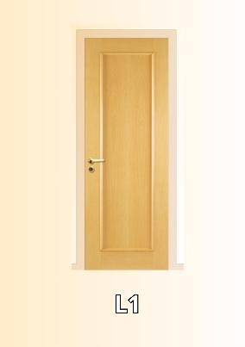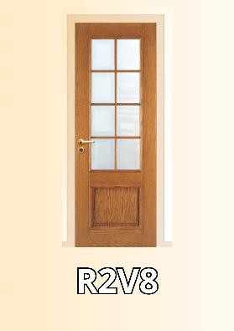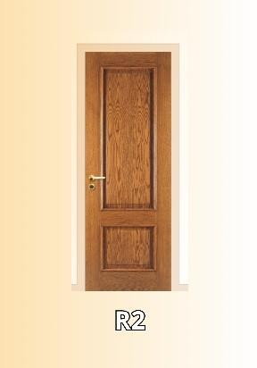

|  |  |  |  |  |  |
| --- | --- | --- | --- | --- | --- |
| 4 | R2 | Inside Door | 200x60 | Dimar | Mahogany |
| 2 | L1EV1 | Inside Door | 200x80 | Dimar | Mahogany |
| 2 | R2 | Inside Door | 200x65 | Dimar | Mahogany |
| 1 | PA12 | Inside Door | 200x65 | Porteme | Mahogany |
| 1 | L2 | Inside Door | 180x75 | Dimar | Mahogany |
| 1 | R2PV8 | Inside Door | 200x65 | Dimar | Mahogany |
| 1 | R2PV8 | Inside Door | 200x65 | Dimar | Mahogany |
| 1 | R2EV8 | Inside Door | 200x65 | Dimar | Mahogany |
| 2 | R2P | Inside Door | 210x60 | Dimar | Mahogany |
| 1 | L2 | Inside Door | 200x60 | Dimar | Mahogany |
| 1 | L1 | Inside Door | 200x70 | Dimar | Brazilian Cherry Tree |
| 1 | L2P | Inside Door | 210x70 | Dimar | Mahogany |
| 1 | R2EV8 | Inside Door | 200x65 | Dimar | Mahogany |
| 1 | R2EV12 | Inside Door | 200x80 | Dimar | Mahogany |
| 1 | R2E | Inside Door | 190x65 | Dimar | Mahogany |
| 2 | R2E | Inside Door | 200x60 | Dimar | Mahogany |
| 2 | R2E | Inside Door | 200x60 | Dimar | Kambala |
| 2 | R2E | Inside Door | 200x70 | Dimar | Mahogany |
| 1 | L1V1 | Inside Door | 200x80 | Dimar | Mahogany |
| 2 | R2EV8 | Inside Door | 200x75 | Dimar | Mahogany |
| 1 | R2EV12 | Inside Door | 200x75 | Dimar | Mahogany |
| 1 | L2V8 | Inside Door | 200x65 | Dimar | Mahogany |
| 2 | R1E | Inside Door | 200x80 | Dimar | Mahogany |

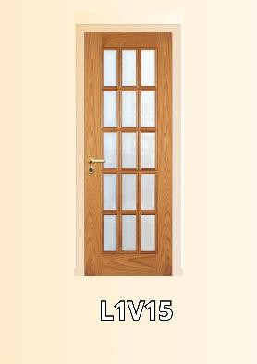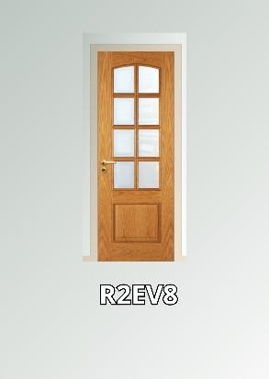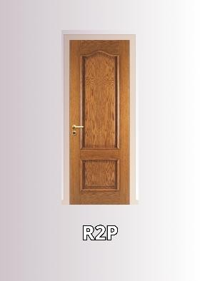

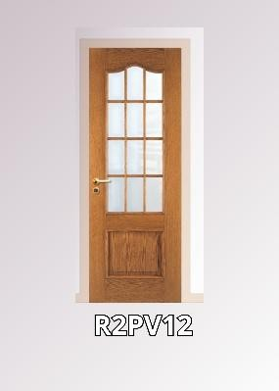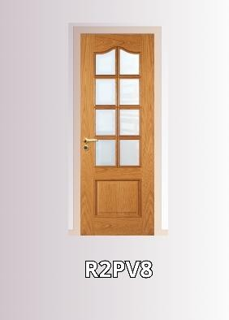

|  |  |  |  |  |  |
| --- | --- | --- | --- | --- | --- |
| 5 | R2EV12 | Inside Door | 200x65 | Dimar | Oak |
| 1 | R2EV8 | Inside Door | 200x65 | Dimar | Mahogany |
| 1 | R2EV8 | Inside Door | 200x65 | Dimar | Tola Wood |
| 1 | L1V1 | Inside Door | 200x65 | Dimar | Oak |
| 1 | R2EV12 | Inside Door | 200x75 | Dimar | Oak |
| 1 | L2 | Inside Door | 190x80 | Dimar | Oak |
| 1 | L2V12 | Inside Door | 200x75 | Dimar | Mahogany |
| 1 | L2V9 | Inside Door | 200x75 | Dimar | Tola Wood |
| 1 | L2V8 | Inside Door | 200x75 | Dimar | Tola Wood |
| 1 | L2P | Inside Door | 200x70 | Dimar | Mahogany |
| 1 | R2P | Inside Door | 200x70 | Dimar | Mahogany |
| 1 | R2PV12 | Inside Door | 200x75 | Dimar | Tola Wood |
| 1 | L1 | Inside Door | 200x75 | Dimar | Beech |
| 1 | R2E | Inside Door | 200x70 | Dimar | Kambala |
| 1 | L2 | Inside Door | 200x70 | Dimar | Beech |
| 1 | R2EV12 | Inside Door | 200x75 | Dimar | Brazilian Cherry Tree |
| 1 | R2V8 | Inside Door | 200x65 | Dimar | Brazilian Cherry Tree |
| 1 | L1V12 | Inside Door | 200x60 | Dimar | Mahogany |
| 1 | L2V12 | Inside Door | 200x65 | Dimar | Mahogany |
| 8 | R2V8 | Inside Door | 200x65 | Dimar | Mahogany |
| 1 | L1V10 | Inside Door | 200x70 | Dimar | Mahogany |
| 1 | R2V8 | Inside Door | 200x60 | Dimar | Mahogany |
| 1 | L1V10 | Inside Door | 200x65 | Dimar | Mahogany |

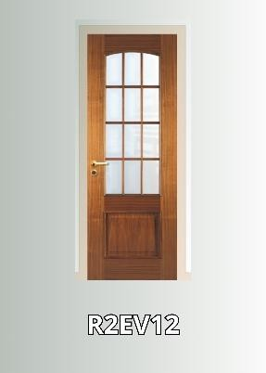

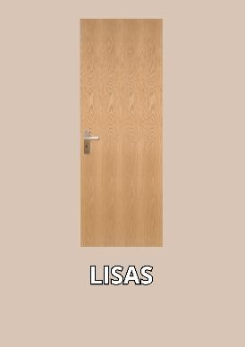

|  |  |  |  |  |  |
| --- | --- | --- | --- | --- | --- |
| 1 | L1PV10 | Inside Door | 200x60 | Dimar | Mahogany |
| 2 | L1PV10 | Inside Door | 200x65 | Dimar | Mahogany |
| 6 | L1V1 | Inside Door | 200x65 | Dimar | Mahogany |
| 1 | L1V15 | Inside Door | 200x80 | Dimar | Mahogany |
| 1 | L1EV12 | Inside Door | 200x80 | Dimar | Mahogany |
| 2 | L1V10 | Inside Door | 200x65 | Dimar | Mahogany |
| 6 | L1EV10 | Inside Door | 200x65 | Dimar | Mahogany |
| 2 | R2 | Inside Door | 200x65 | Dimar | Mahogany |
| 1 | R2P | Inside Door | 200x85 | Dimar | Mahogany |
| 2 | R2P | Inside Door | 200x55 | Dimar | Mahogany |
| 1 | R2V12 | Inside Door | 200x65 | Dimar | Brazilian Cherry Tree |
| 1 | L2 | Inside Door | 200x65 | Dimar | Mahogany |
| 4 | R2V8 | Inside Door | 200x60 | Dimar | Mahogany |
| 1 | R2P | Inside Door | 200x55 | Dimar | Mahogany |
| 1 | L2P | Inside Door | 200x75 | Dimar | Mahogany |
| 1 | L2P | Inside Door | 200x70 | Dimar | Mahogany |
| 1 | R2V8 | Inside Door | 200x75 | Dimar | Beech |
| 1 | R2V8 | Inside Door | 200x65 | Dimar | Beech |
| 1 | L2 | Inside Door | 200x75 | Dimar | Tola Wood |
| 1 | L2P | Inside Door | 200x70 | Dimar | Tola Wood |
| 1 | L2PV12 | Inside Door | 200x75 | Dimar | Tola Wood |
| 2 | L1 | Inside Door | 200x80 | Dimar | Tola Wood |
| 4 | R2E | Inside Door | 200x65 | Dimar | Mahogany |

|  |  |  |  |  |  |
| --- | --- | --- | --- | --- | --- |
| 4 | R2V8 | Inside Door | 200x65 | Dimar | Oak |
| 1 | R2PV12 | Inside Door | 200x75 | Dimar | Oak |
| 2 | R2V8 | Inside Door | 200x75 | Dimar | Oak |
| 2 | R2V8 | Inside Door | 200x90 | Dimar | Oak |
| 1 | PA12 | Inside Door | 200x80 | Porteme | Oak |
| 1 | R2PV12 | Inside Door | 200x85 | Dimar | Oak |
| 2 | R2E | Inside Door | 200x60 | Dimar | Tola Wood |
| 2 | R2EV8 | Inside Door | 200x70 | Dimar | Kambala |
| 2 | R2E | Inside Door | 200x45 | Dimar | Tola Wood |
| 1 | L2V8 | Inside Door | 200x85 | Dimar | Tola Wood |
| 1 | L1V15 | Inside Door | 200x75 | Dimar | Tola Wood |
| 1 | R2V8 | Inside Door | 200x85 | Dimar | Tola Wood |
| 1 | RE2EV8 | Inside Door | 200x60 | Dimar | Tola Wood |
| 1 | R2EV12 | Inside Door | 200x70 | Dimar | Tola Wood |
| 2 | PA12 | Inside Door | 200x65 | Porteme | Mahogany |
| 4 | PA8 | Inside Door | 200x60 | Porteme | Mahogany |
| 1 | PA12 | Inside Door | 200x75 | Porteme | Tola Wood |
| 17 | PA8 | Inside Door | 200x70 | Porteme | Tola Wood |
| 2 | PA8 | Inside Door | 200x65 | Porteme | Tola Wood |
| 18 | PA8 | Inside Door | 200x60 | Porteme | Tola Wood |
| 24 | R2P | Inside Door | 200x80 | Dimar | Mahogany |
| 1 | L2V8 | Inside Door | 200x80 | Dimar | Oak |
| 4 | R2 | Inside Door | 200x80 | Dimar | Oak |

|  |  |  |  |  |  |
| --- | --- | --- | --- | --- | --- |
| 2 | R2 | Inside Door | 200x75 | Dimar | Mahogany |
| 3 | R2 | Inside Door | 200x90 | Dimar | Mahogany |
| 16 | 2 alm. Bites | Inside Door | 200x60 | Porteme | Mahogany |
| 25 | 2 alm. Bites | Inside Door | 200x80 | Porteme | Mahogany |
| 20 | 2 alm. Bites | Inside Door | 200x65 | Porteme | Mahogany |
| 2 | 2 alm. Bites | Inside Door | 200x70 | Porteme | Mahogany |
| 42 | 2 alm. Bites | Inside Door | 200x75 | Porteme | Mahogany |
| 4 | 2 alm. Bites | Inside Door | 200x60 | Porteme | Mahogany |
| 30 | 2 alm. Bites | wardrobe Door | 180x50 | Porteme | Mahogany |
| 12 | 2 alm. Bites | wardrobe Door | 180x60 | Porteme | Mahogany |
| 42 | 2 alm. Bites | wardrobe Door | 180x45 | Porteme | Mahogany |
| 30 | 1 alm. Bites | Small Wardrope door | 50x50 | Porteme | Mahogany |
| 60 | L1 | Small Wardrope door | many sizes | Dimar | Mahogany |
| 130 | R1E | Small Wardrope door | 50x40 | Dimar | Mahogany |
| 4 | L2 | wardrobe Door | 180x50 | Dimar | Mahogany |
| 4 | L2 | wardrobe Door | 180x60 | Dimar | Mahogany |
| 20 | R2P | wardrobe Door | 180x45 | Dimar | Mahogany |
| 20 | R2P | wardrobe Door | 180x50 | Dimar | Mahogany |
| 5 | R2E | wardrobe Door | 180x55 | Dimar | Mahogany |
| 32 | 1Alm. Bites | wardrobe Door | 180x45 | Porteme | Mahogany |
| 58 | Lisas | Inside Door | 200x65 | Porteme | Tola Wood |
| 27 | Lisas | Inside Door | 200x65 | Porteme | Kambala |
| 8 | Lisas | Inside Door | 200x60 | Porteme | Kambala |

|  |  |  |  |  |  |  |
| --- | --- | --- | --- | --- | --- | --- |
| 42 | Lisas | Inside Door | 200x60 | Porteme | Oak |  |
| 44 | Lisas | Inside Door | 200x60 | Porteme | Pine |
| 10 | Lisas | Inside Door | 200x65 | Porteme | Pine |
| 15 | Lisas22mm | wardrobe Door | 200x55 | Porteme | Oak |
| 6 | Lisas22mm | wardrobe Door | 200x50 | Porteme | Oak |
| 5 | Lisas22mm | wardrobe Door | 200x65 | Porteme | Pine |
| 17 | Lisas29mm | wardrobe Door | 200x100 | Porteme | Pine |
| 8 | Lisas29mm | wardrobe Door | 200x80 | Porteme | Pine |
| 8 | Lisas29mm | wardrobe Door | 200x90 | Porteme | Pine |
| 15 | Lisas29mm | wardrobe Door | 200x45 | Porteme | Pine |
| 13 | Lisas29mm | wardrobe Door | 200x55 | Porteme | Mahogany |
| 47 | Lisas29mm | wardrobe Door | 200x50 | Porteme | Mahogany |
| 77 | Lisas29mm | wardrobe Door | 200x45 | Porteme | Mahogany |
| 32 | Lisas29mm | wardrobe Door | 200x40 | Porteme | Mahogany |
| 25 | Lisas | Inside Door | 200x75 | Porteme | Blatex |
| 1229 |  | | | | | |